Write a 2D list to a CSV file

# Code snippet .

Takes a 2D list of integers, creates a new 2D list with the same values as the string data type, and joins the 2D list into a string with a comma between each item and a new line between each row. Writes the single string to a CSV file.

| 1  2  3  4  5  6  7  8  9  10  11  12  13  14  15  16  17  18  19  20 | number_grid = [[1, 2, 3],  [4, 5, 6],  [7, 8, 9]]  str_number_grid = []  for item in number_grid:  row = []  for number in item:  row.append(str(number))  str_number_grid.append(row)  data = ""  for x in range(3):  data = data + ",".join(str_number_grid[x]) + "\n"  file = open("number_grid.csv", "w")  file.write(data)  file.close() |
| --- | --- |

Challenge 1 .100 number square

**Challenge**

Create a program that performs the following:

* Automatically populates a 2D list that holds a 100 number square
* Writes the data from the 2D list to a CSV file

**The finished CSV file should look like the example below when opened with spreadsheet software:**

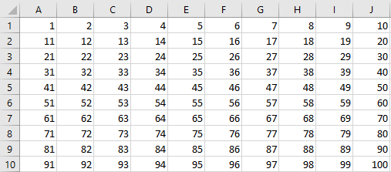

**Test your code then enter it below:**

|  |
| --- |

# Challenge 2 .FizzBuzz number square

**Challenge**

A teacher would like a number square that reveals the correct answers for a game of FizzBuzz. If the number is a multiple of two, the word should be replaced with Fizz. If the number is a multiple of five, then it should be replaced with Buzz. If it is a multiple of two and five, then it should be replaced with FizzBuzz.

Create a program that performs the following:

* Automatically generates the FizzBuzz number square using the above conditions
* Writes the number square to a CSV file so that it can be easily printed by the teacher

**The finished CSV file should look like the example below:**

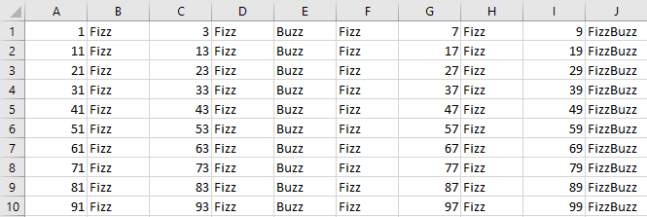

**Test your code then enter it below:**

|  |
| --- |

# Explorer task . Extend the FizzBuzz number square program

The user of the program should be able to enter any two numbers for Fizz and Buzz. These two numbers should be used to automatically generate a 100 number square for that FizzBuzz game.

|  |
| --- |

# 